

Curriculum Design for Science and Maths Sub-Topics aligned to CBE Grade 10
Scheme of Work for

Subject: Physics
Strand / Topic: # and Name: Waves and Optics
Sub-strand / Sub-Topic: # and Name:Radioactivity and Stability of Isotopes
Author: Okello

Curriculum Design: The lesson/unit is designed for students to make sense of phenomena and/or design solutions to problems by engaging in student sense making

Learning Outcomes: What will the students know and be able to do by the end of the Unit? What are the key scientific principles/key concepts that we want students to learn in this unit?

1. Knowledge and Understanding
By the end of the sub-strand, the learner should be able to:

Explain terminologies used in radioactivity such as isotope, nuclide, half-life, background radiation.

Identify and describe types and properties of radioactive emissions (α, β, γ).

Illustrate, using nuclear equations, how radionuclides attain stability.

State the significance of half-life and its use in dating and medical applications.

Explain the processes of nuclear fission, fusion, and chain reactions.

Describe medical and industrial applications of radioactivity and associated safety precautions.

2.Practical Skills
By the end of the sub-strand, the learner should be able to:

Demonstrate the detection of radioactive emissions using simulations, charts, or simple experimental setups (Geiger counter, cloud chamber).

Construct and interpret nuclear equations for decay processes and stability.

Perform calculations involving half-life of common radioactive isotopes and represent them graphically.

Model chain reactions to show how nuclear fission and fusion occur.

Use print and non-print resources (YouTube, PhET, Khan Academy, LabExchange) to research and present findings on safety measures and applications of radioactivity.

3. Attitude and Values
By the end of the sub-strand, the learner should be able to:

Show responsibility and care when discussing or simulating handling of radioactive substances.

Appreciate the importance of nuclear science in medicine, industry, and energy production.

Develop critical awareness of the dangers of radiation misuse and the importance of safety precautions.

Demonstrate teamwork and respect while working with peers on simulations and discussions.

Cultivate curiosity and appreciation for scientific problem solving in addressing energy and health issues using radioactivity.

Chapter and/or Unit Criteria  Lessons and units designed so students make sense of a phenomenon-based storyline and/or design solutions to problems.  The design of this unit/chapter includes: | Use Khan or Rachel or Internet to help you identify useful tools  Provide Links to Supporting Documents Found on Rachel or Internet | SENSE-MAKING  - Providing strategies for ensuring student sense-making and/or problem-solving about each lesson.  - Which sense-making tools will you use with each of the lessons you are building into your plan? | FORMATIVE ASSESSMENT:  - Find sample assessments in Rachel or Khan to use.  - Embeds formative assessment opportunities throughout that evaluate student learning to inform instruction.  - Provides multiple opportunities for students to demonstrate their understanding the content and receive feedback
- THE PHENOMENON: Making sense of phenomena and/or designing solutions to a problem drive student learning.  - The phenomenon is current, relevant, real world that can be answered by using science principles, computational skills and/or engineering design solutions.  - The phenomenon is observable and interesting to students. Something they want to figure out.  - The phenomenon is framed as a Driving Question to be figured out in the series of evidence gathering activities  - Student questions and prior experiences related to the phenomenon or problem motivate sense-making and/or problem solving.  - Students show their initial thinking by drawing a model. | Phenomena and Driving Questions – Radioactivity  - Background Radiation in Daily Life  - Phenomenon: Natural radiation from soil, rocks, and cosmic rays can be detected using a Geiger counter.  - Driving Question: How can we detect radiation in our surroundings, and what are safe levels of exposure?  - Radioactive Decay and Half-Life  - Phenomenon: Some isotopes (like carbon-14) decay over time at predictable rates.  - Driving Question: How can we use half-life to determine the age of fossils or radioactive materials  - Alpha, Beta, and Gamma Radiation  - Phenomenon: Different emissions have distinct penetration abilities (e.g., paper stops α, thin metal stops β, thick lead stops γ).  - Driving Question: How do the properties of α, β, and γ radiation affect their use in medicine and industry?  - Nuclear Fission and Chain Reactions  - Phenomenon: Uranium nuclei splitting releases energy, as in nuclear power plants.  - Driving Question: How does a chain reaction produce energy, and how can it be controlled safely?  - Nuclear Fusion in Stars  - Phenomenon: The Sun produces energy by fusing hydrogen nuclei into helium.  - Driving Question: How does nuclear fusion create energy, and can we replicate it for clean power on Earth?  - Medical Applications of Radioactivity  - Phenomenon: Radioisotopes are used in cancer treatment, X-rays, and diagnostic scans.  - Driving Question: How can radioactive materials help diagnose and treat diseases safely?  - Industrial Uses of Radioactivity  - Phenomenon: Radioactive sources detect leaks, measure thickness, and sterilize medical equipment.  - Driving Question: How can radiation be applied in industry without harming people?  - Radiation Safety Awareness  - Phenomenon: Protective shields, distance, and time reduce radiation exposure.  - Driving Question: What safety measures must we use when handling radioactive materials to minimize risk? | Learners watch the Geiger counter demo, then use PhET sims to explore how nuclei emit radiation. They discuss:  - Why some isotopes are stable while others decay.  - How α, β, and γ radiation differ in penetration, mass, and charge. | -Quick quiz: Identify α, β, and γ from given properties.  -Exit ticket: “Why does an unstable nucleus emit radiation?”
PREPARE A MODEL SCAFFOLD
- A place for students to draw, write, discuss their initial ideas about the phenomenon
- Driving Question Board as an option to collect students’ initial ideas and questions after they draw their initial model.
PLAN FOR DRAWING UPON STUDENTS’ PRIOR KNOWLEDGE

Includes suggestions for how to connect instruction to the students' home, neighborhood, community and/or culture as appropriate.
  - Provides opportunities for students to connect their explanation of a phenomenon and/or their design solution to a problem to questions from their own experience.

Chapter and/or Unit Criteria  Lessons and units designed so students make sense of a phenomenon-based storyline and/or design solutions to problems.  The design of this unit/chapter includes: | Use Khan, Rachel, SV for Teachers, LabXchange, or Internet to help you identify useful tools  Provide Links to Supporting Documents Found on Rachel or Internet | SENSE-MAKING  - Providing strategies for ensuring student sense-making and/or problem-solving about each lesson.  - Which sense-making tools will you use with each of the lessons you are building into your plan?  - Teacher moves | FORMATIVE ASSESSMENT:  - Find sample assessments in Rachel or Khan to use.  - Embeds formative assessment opportunities throughout that evaluate student learning to inform instruction.  - Provides multiple opportunities for students to demonstrate their understanding the content and receive feedback
LESSON SEQUENCE  - Give a general outline of the lessons that will be used to teach this topic | Resources : PhET, Khan, YouTube (from above, sequenced).  Sequence:  - Terminologies & isotopes  - Types of radiation (α, β, γ)  - Detection of radiation  - Half-life & decay curves  - Nuclear equations  - Fission & fusion  - Applications & safety  - Review & reflection | -Learners explore nuclear terminology & isotopes (Build a Nucleus simulation).  -Groups investigate properties of α, β, γ radiation through demos and sims.  -Students observe detection methods using Geiger counter videos and record observations.  -Learners simulate half-life with coins and PhET, plotting decay curves.  -Groups balance nuclear equations for α and β decays.  -Class explores fission chain reactions and compares with fusion.  -Learners research and present applications and safety precautions.  -Teacher leads review discussion, linking all lessons to daily life and national issues. | -Spot checks after each step (e.g., oral Q: “Which radiation penetrates furthest?”).  -Group worksheets for half-life and nuclear equations.  -Exit tickets summarizing one key idea per lesson.  -Peer marking of application posters.
- THE EVIDENCE GATHERED: What are the lessons you will use in your class to help your student collect evidence to answer the Driving Question/ figure out the phenomenon?  - Provides at least 4 opportunities to gather evidence through (readings, practicals, simulations, videos)  - The focus of each lesson is to support students in making sense of phenomena and/or designing solutions to the problems and prior student experiences.  - Each lesson builds on prior lessons by addressing questions raised in those lessons, cultivating new questions that build on what students figured out, or cultivating new questions from related phenomena.  - Provides strategies for linking student engagement across lessons (revisit the model and add to the model as evidence is gathered and students figure it out). | - Types of Radiation (α, β, γ)  - YouTube demo: Alpha, Beta, Gamma with Geiger counter →Here  - PhET Alpha Decay →Here  - PhET Beta Decay →Here  - Detection of Radiation  - YouTube: Using a Geiger counter →Here  - Reading: Cloud chamber basics (Khan Academy nuclear physics section)  - Half-Life Measurement  - YouTube: Half-life coin toss demo →Here  - PhET Alpha Decay (with adjustable sample size for half-life curves)  - Nuclear Equations & Stability  - Khan Academy: Writing nuclear equations →Here  - PhET Build a Nucleus → https://phet.colorado.edu/en/simulation/build-a-nucleus  - Applications & Safety  - IAEA: Radiation Protection Basics →Here  - YouTube: Smoke detector with americium →Here | Lesson 1 – Types of Radiation  - Learners: Observe differences in penetration and ionisation; update the class model with: α (heavy but low penetration), β (moderate), γ (highly penetrating).  - Teacher moves: Demonstrates safe simulations or shows diagrams of radiation, asks probing questions to compare penetration abilities, clarifies misconceptions, and guides learners in updating the model accurately.  Lesson 2 – Detection  - Learners: Connect that invisible emissions can be detected reliably; revise model: radiation is unseen but measurable using instruments.  - Teacher moves: Introduces detection tools (simulations, Geiger counters, cloud chamber demos), explains how they work, prompts learners to interpret readings, and ensures observations are correctly recorded in the model.  Lesson 3 – Half-Life  - Learners: Simulate decay curves; update model: decay is random for atoms but predictable for large samples.  - Teacher moves: Guides learners through simulations or experiments, explains the concept of half-life, asks reflective questions about patterns, and helps learners link results to the model.  Lesson 4 – Nuclear Equations  - Learners: Groups write and balance nuclear equations; add to model: decay changes element identity and proton/neutron balance.  - Teacher moves: Demonstrates how to write and balance equations, checks for accuracy, provides feedback, and supports learners in correctly updating the class model.  Lesson 5 – Applications & Safety  - Learners: Link uses and risks, updating model: radioactivity can be harnessed but requires safety controls.  - Teacher moves: Presents real-life examples (medicine, industry, energy), emphasizes safety precautions, asks learners to discuss and justify safe practices, and ensures the model reflects both benefits and risks. | Lesson 1: Exit ticket: “Which radiation is most dangerous outside the body and why?”  Lesson 2: Group Q&A: “Name two ways radiation can be detected.”  Lesson 3: Graph check: Students submit decay curves with labeled half-life.  Lesson 4: Worksheet: Balance two nuclear decay equations.  Lesson 5: Peer-assessed poster: “Applications of Radioactivity and Safety Precautions.”
PLAN FOR THE SUMMARY TABLE HERE  - Create the summary table template here which includes the lesson title, a description of what was learned, and a place to reflect on how the lesson helps to explain the phenomenon. | Activity What did I observe? What did I learn? How does this explain the phenomena?  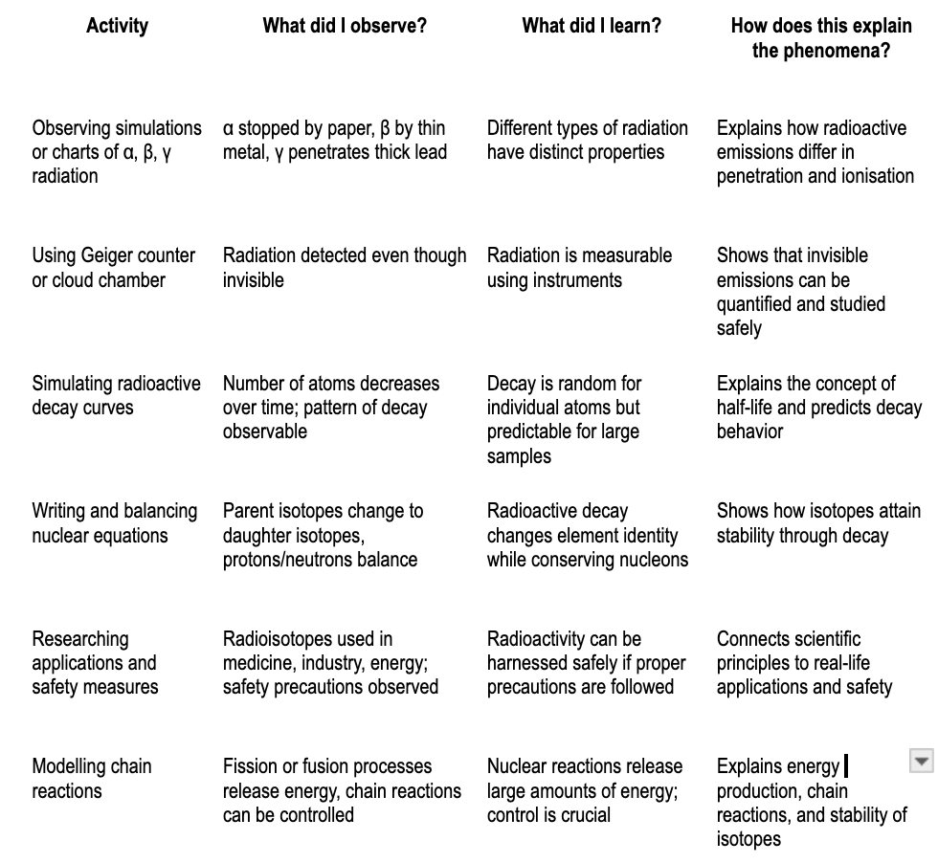 | Learners explore neutron–proton ratios and construct the “belt of stability” to explain why some nuclei are stable.  In groups, learners compare α, β, and γ radiation in terms of penetration, charge, and mass, then relate these to real-life applications.  Learners observe or simulate how detectors like the Geiger counter or cloud chamber function, then discuss their use in medicine and environmental monitoring.  Learners simulate radioactive decay curves to visualise half-life, then connect this to fossil dating and use in medicine.  Learners compare nuclear fission and fusion in terms of energy released, and evaluate their peaceful vs destructive applications.  Learners discuss medical, agricultural, and industrial applications of radioactivity, weighing benefits against dangers such as nuclear accidents or waste. | Quick quiz: classify isotopes as stable or unstable and justify.  Group comparison chart of α, β, and γ radiation properties.  Individual sketch-and-label exercise of a radiation detection device, explaining its working principle.  Short worksheet on half-life: calculate values and plot decay graphs.  Class debate: “Fusion is the future of clean energy”.  Reflective writing: “How can radioactivity be used safely in my community?”.
- FINAL EXPLANATION:  What will students be able to explain when they are finished with the Unit/Chapter?  Expectation for the final explanation: (citing evidence gathered that helps explain the scientific principles for this chapter/unit)?  Write out the final explanation here.  - Uses scientifically accurate and grade- appropriate scientific information to explain the phenomena | Revisit the Driving questions to identify what evidence students have gathered to help them answer the questions.  Radioactivity and Stability of Isotopes – Final Explanation  Atoms consist of protons, neutrons, and electrons. Some atoms have unstable nuclei due to an imbalance in the number of protons and neutrons. These unstable atoms, called radioisotopes, emit radiation in the form of alpha (α), beta (β), or gamma (γ) rays to become more stable. Alpha particles are heavy and have low penetration, beta particles are lighter with moderate penetration, and gamma rays are highly penetrating electromagnetic waves.  The process of radioactive decay is random for individual atoms, but for large numbers of atoms, it follows a predictable pattern described by the half-life, which is the time taken for half of a sample to decay. Radioactive decay can be represented using nuclear equations, showing how unstable nuclei transform into more stable daughter nuclei while conserving protons and neutrons.  Radioactivity has many practical applications. In medicine, radioisotopes are used in cancer treatment, imaging, and sterilization. In industry, they help in measuring thickness, detecting leaks, and generating energy through controlled nuclear fission. Nuclear fusion, which powers the Sun, demonstrates how combining nuclei releases enormous energy.  Understanding radioactivity also requires safety awareness, as radiation can be harmful if not handled correctly. By studying radioactive decay, isotopes, and chain reactions, learners can connect the science to real-life phenomena, predict behavior of radioactive materials, and appreciate both the benefits and risks of nuclear science. | What is the plan for helping students write this final explanation? (Use their final Model. Summary Table.)  Teacher leads learners to summarize key takeaways:  • Why nuclei become unstable.  • Differences between α, β, γ radiation.  • How half-life explains predictability in decay.  • Real-life uses and risks of radioactivity.  Learners connect radioactivity to everyday contexts (medical imaging, food preservation, smoke detectors). | -5-minute written quiz: “State two dangers and two uses of radioactivity.”  -Exit ticket: “In one sentence, explain why radioactivity is both useful and dangerous.”  -Group reflection: learners discuss which application of radioactivity impressed them most and why.

CBE REQUIREMENTS REFERENCED IN THIS UNIT | Clearly articulate how these topics are addressed in this unit
Core competencies* (digital literacy, citizenship, learning to learn, collaboration/communication, critical thinking/problem solving, self-efficacy, imagination/creativity) addressed in this Curriculum Design | Core Competencies addressed  - Digital literacy: Learners use online simulations (PhET decay series, half-life demos) and YouTube/Khan Academy to collect and analyse radioactive data.  - Citizenship: Learners discuss nuclear safety and responsible handling of radioactive materials, linking to national and global safety standards (e.g. Chernobyl, Fukushima).  - Learning to learn: Students engage in hands-on and inquiry-based activities (cloud chamber demo, half-life experiments) and refine their models lesson by lesson.  - Collaboration/communication: Learners work in groups to research applications of radioactivity (medicine, industry) and present findings through posters or presentations.  - Critical thinking/problem solving: Learners analyse radiation detection methods and apply nuclear equations to predict stability.  - Self-efficacy: Learners build confidence by carrying out activities such as half-life simulations and presenting safety precautions.  - Imagination/creativity: Learners create charts, posters, or models illustrating decay processes, nuclear fission, and safe use of radioisotopes.
Which Core Values** are addressed? (Nationalism and patriotism, Respect, Responsitillity, Integrity, Peace and Social Justice, Love, Unity, Excellence, Care and Compassion, Tolerance, Ethics) (do this by using Norms?) | Core Values addressed  - Responsibility: Handling experiments carefully and reporting accurate observations.  - Integrity: Honest recording of radioactive decay results and group findings.  - Respect: Valuing peers’ contributions during group discussions on safety and nuclear applications.  - Peace and Social Justice: Understanding the risks of nuclear weapons vs. peaceful nuclear use in energy and medicine.  - Care and Compassion: Awareness of radiation effects on humans/environment and advocating for safety.  - Unity & Tolerance: Working in diverse teams to solve problems and present ideas.  - Excellence: Encouragement to apply best practices in scientific inquiry and reporting.
Which pertinent and contemporary issues are/ or could be addressed in this scheme of work? | Pertinent and Contemporary Issues (PCIs)  - Health & Safety: Safe disposal of radioactive waste, radiation exposure in hospitals (X-rays, cancer treatment).  - Environmental conservation: Preventing pollution by radioactive emissions and managing nuclear accidents.  - Socio-economic issues: Role of nuclear power in energy production, balancing benefits vs. risks.  - Ethics: Debate on nuclear weapons vs. peaceful uses of nuclear science.  - Technology & innovation: Advances in nuclear medicine (PET scans, radiotherapy) and industry (tracer studies).
Are there careers that might use this knowledge | Careers linked to this knowledge  - Nuclear physicist  - Medical physicist / radiologist  - Radiation safety officer  - Nuclear engineer  - Environmental scientist  - Energy sector (nuclear power plants)  - Industrial quality control technician (using isotopes for thickness gauges, weld testing)
Do we need to create Rubrics for any of the embedded assessments? If so list those here: | Rubrics to be developed for embedded assessments  - Experiment report rubric: Accuracy in recording half-life experiment, clarity of graphs, correct conclusion.  - Group discussion rubric: Participation, respect, contribution of ideas on safety precautions.  - Poster/presentation rubric: Accuracy, creativity, clarity when explaining applications of radioactivity.  - Problem-solving rubric: Correct balancing of nuclear equations and explanation of isotope stability.

*CORE COMPETENCIES:
- Communication and Collaboration:.
- Emphasizes the ability to effectively communicate ideas and work with others.
- Self-efficacy:.
- Focuses on building learners' confidence and belief in their ability to succeed.
- Critical Thinking and Problem Solving:.
- Encourages learners to analyze information, solve problems, and make informed decisions.
- Digital Literacy:.
- Develops the skills to effectively and safely use technology and digital tools.
- Learning to Learn:.
- Fosters a mindset of continuous learning and the ability to acquire new knowledge and skills independently.
- Citizenship:.
- Promotes an understanding of civic responsibilities and active participation in society.
- Creativity and Innovation: .
- Encourages learners to think creatively, generate new ideas, and find innovative solutions.

**CORE VALUES:
- Nationalism and Patriotism: Instilling a sense of national unity, identity, and pride in Kenya.
- Respect: Fostering respect for oneself, others, and cultural diversity.
- Responsibility: Developing a sense of responsibility towards oneself, the community, and the environment.
- Integrity: Promoting honesty, ethical behavior, and moral principles.
- Peace and Social Justice: Encouraging harmonious coexistence and equitable treatment of all.
- Love: Creating a supportive and caring learning environment.
- Unity: Promoting togetherness and social cohesion.
- Excellence: Striving for high standards in all endeavors.
- Care and Compassion: Developing empathy and concern for the well-being of others.
- Tolerance: Fostering understanding and acceptance of different perspectives.
- Ethics: Instilling a strong moral compass and ethical decision-making.

Activity | What did I observe? | What did I learn? | How does this explain the phenomena?
Observing simulations or charts of α, β, γ radiation | α stopped by paper, β by thin metal, γ penetrates thick lead | Different types of radiation have distinct properties | Explains how radioactive emissions differ in penetration and ionisation
Using Geiger counter or cloud chamber | Radiation detected even though invisible | Radiation is measurable using instruments | Shows that invisible emissions can be quantified and studied safely
Simulating radioactive decay curves | Number of atoms decreases over time; pattern of decay observable | Decay is random for individual atoms but predictable for large samples | Explains the concept of half-life and predicts decay behavior
Writing and balancing nuclear equations | Parent isotopes change to daughter isotopes, protons/neutrons balance | Radioactive decay changes element identity while conserving nucleons | Shows how isotopes attain stability through decay
Researching applications and safety measures | Radioisotopes used in medicine, industry, energy; safety precautions observed | Radioactivity can be harnessed safely if proper precautions are followed | Connects scientific principles to real-life applications and safety
Modelling chain reactions | Fission or fusion processes release energy, chain reactions can be controlled | Nuclear reactions release large amounts of energy; control is crucial | Explains energy production, chain reactions, and stability of isotopes

